1. **Fix the bugs in below snippet**

**<html lang="en">**

**<head>**

**<title>Document**

**<body>**

**guvi**

**</title>**

**</head>**

**<div>**

**Lorem ipsum dolor sit amet consectetur adipisicing elit.**

**<div>**

**<div>**

**Guvi Geek Network**

**</div>**

**</body>**

**</html>**

**Answer: 1**

<html lang="en">

<head>

    <title>Document guvi</title>

</head>

<body>

    <div>

        Lorem ipsum dolor sit amet consectetur adipisicing elit.

    </div>

    <div>

        Guvi Geek Network

    </div>

</body>

</html>

1. **Try the below one**

**<html lang="en">**

**<head>**

**<title>Document**

**<body>**

**guvi**

**</head>**

**<div>**

**Lorem ipsum dolor sit amet consectetur adipisicing elit.**

**<div>**

**<div>**

**Guvi Geek Network**

**</div>**

**</body>**

**</html>**

**Answer 2:**

<html lang="en">

<head>

    <title>Document guvi </title>

</head>

<body>

    <div>

        Lorem ipsum dolor sit amet consectetur adipisicing elit.

    </div>

    <div>

        Guvi Geek Network

    </div>

</body>

</html>

1. **Design a contact us form with all fields as required.**

**Answer 3:**

<!DOCTYPE html>

<html lang="en">

  <head>

    <meta charset="UTF-8" />

    <meta http-equiv="X-UA-Compatible" content="IE=edge" />

    <meta name="viewport" content="width=device-width, initial-scale=1.0" />

    <title>Document</title>

  </head>

  <body>

<section>

<form>

    <br id="contact">

        <h1 class="h-primary center">Contact Us</h1>

        <div id="contact-box">

            <form action="">

                <div class="form-group">

                    <label for="name">Name: </label>

                    <input type="text" name="name" id="name" placeholder="Enter your name">

                </div>

                <div class="form-group">

                    <label for="email">Email: </label>

                    <input type="email" name="name" id="email" placeholder="Enter your email">

                </div>

                <div class="form-group">

                    <label for="phone">Phone number: </label>

                    <input type="phone" name="name" id="phone" placeholder="Enter your phone">

                </div>

                <div class="form-group">

                    <label for="message">Message: </label>

                    <textarea name="message" id="message" cols="30" rows="10"></textarea>

                </div>

            </form>

        </div>

    </section>

</form>

  </body>

</html>

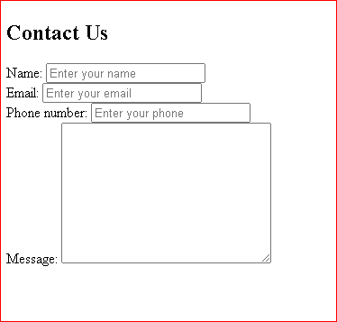

1. **Use certain HTML elements to display the following in a HTML page.**

* **Programming Language**
  + **JavaScript**
    1. **Angular**
    2. **React**
    3. **Vue.js**
  + **Python**
    1. **Django Framework**
    2. **Flask Framework**
  + **Java**
    1. **Spring**
    2. **Maven**
    3. **Hibernate**
* **Database**
  + **MySQL**
  + **MongoDB**
  + **Cansandra**

**Answer 4:**

<!DOCTYPE html>

<html lang="en">

  <head>

    <meta charset="UTF-8" />

    <meta http-equiv="X-UA-Compatible" content="IE=edge" />

    <meta name="viewport" content="width=device-width, initial-scale=1.0" />

    <title>Document</title>

  </head>

  <body>

    <ul type="disc">

      <li>Programming Language</li>

      <dd><li type="circle">Javascript</li></dd>

      <ol type="a">

        <dd><li>Angular</li></dd>

        <dd><li>React</li></dd>

        <dd><li>Vue.js</li></dd>

</ol>

      <dd><li type="circle">Python</li></dd>

      <ol type="a">

        <dd><li>DJango Framewrok</li></dd>

        <dd><li>Flask Framework</li></dd>

</ol>

     <dd><li type="circle">Java</li></dd>

      <ol type="a">

        <dd><li>Spring</li></dd>

        <dd><li>Maven</li></dd>

        <dd><li>Hibernate</li></dd>

</ol>

      <li type="disc">Data base</li>

      <ol type="a">

        <li>My SQL</li>

        <li>Mongo DB</li>

        <li>Cansandra</li>

</ol>

    </ul>

  </body>

</html>

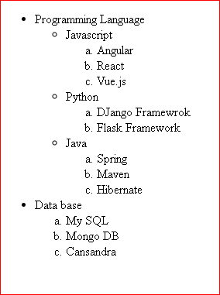

1. **Create an element that helps you to open the**[**https://google.com**](https://google.com/)**in separate new tab.**

**Answer 5:**

<!DOCTYPE html>

<html lang="en">

<head>

    <meta charset="UTF-8">

    <meta http-equiv="X-UA-Compatible" content="IE=edge">

    <meta name="viewport" content="width=device-width, initial-scale=1.0">

    <title>Document</title>

</head>

<body>

    <a href="https://google.com/" target="_blank">Google</a>

</body>

</html>

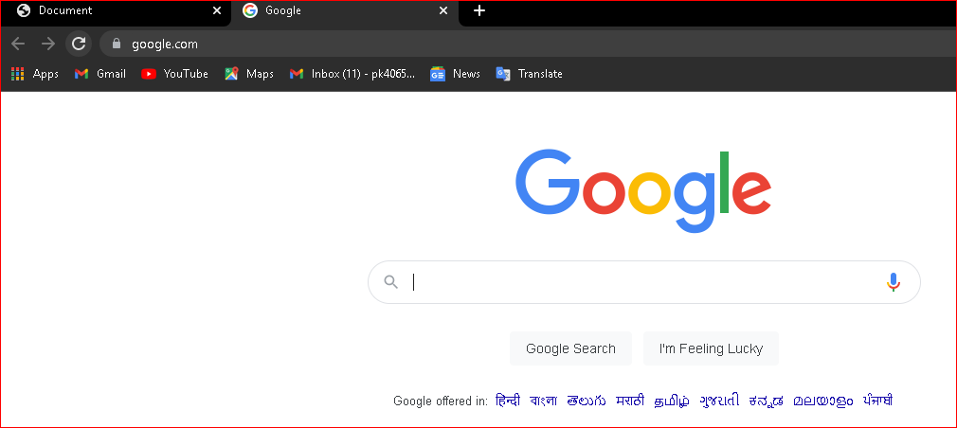

1. **In the form, add two radio buttons with grouping them for employee type(Salaried and own business)**

**Answer 6:**

<!DOCTYPE html>

<html lang="en">

  <head>

    <meta charset="UTF-8" />

    <meta http-equiv="X-UA-Compatible" content="IE=edge" />

    <meta name="viewport" content="width=device-width, initial-scale=1.0" />

    <title>Document</title>

  </head>

  <body>

<section>

<form>

    <br id="contact">

        <h1 class="h-primary center">Contact Us</h1>

        <div id="contact-box">

            <br action="">

                <div class="form-group">

                    <label for="name">Name: </label>

                    <input type="text" name="name" id="name" placeholder="Enter your name">

                </div>

                <div class="form-group">

                    <label for="email">Email: </label>

                    <input type="email" name="name" id="email" placeholder="Enter your email">

                </div>

                <div class="form-group">

                    <label for="phone">Phone number: </label>

                    <input type="phone" name="name" id="phone" placeholder="Enter your phone">

                </div>

                <div class="form-group">

                    <label for="message">Message: </label>

                    <textarea name="message" id="message" cols="30" rows="10"></textarea>

                </div></br>

                <h4>Employee type</h4>

                <input type="radio" id="html" name="fav_language" value="HTML">

                <label for="html">Salaried</label><br>

                <input type="radio" id="css" name="fav_language" value="CSS">

                <label for="css">Own Business</label><br>

            </form>

        </div>

    </section>

</form>

  </body>

</html>

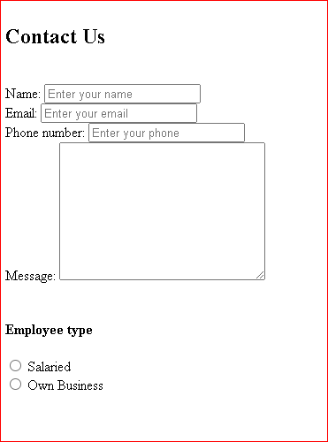

1. **Design form shown in the link (**[**http://evc-cit.info/cit040/formguide/card_0.png**](http://evc-cit.info/cit040/formguide/card_0.png)**)**

**Answer 7:**

<!DOCTYPE html>

<html lang="en">

<head>

    <meta charset="UTF-8">

    <meta http-equiv="X-UA-Compatible" content="IE=edge">

    <meta name="viewport" content="width=device-width, initial-scale=1.0">

    <link rel="stylesheet" href="indexform.css">

    <title>Document</title>

</head>

<body>

    <div id="total">

        <header>

            Yes! I want to subscribe to Mag-O-Zine

        </header>

        <table id="one">

            <tr>

                <td>

                    <input type="text" name="first_name">

                </td>

                <td>

                    <input type="text" name="last_name">

                </td>

            </tr>

            <tr>

                <td>

                    <lable for="first_name">First Name</lable>

                </td>

                <td>

                    <lable for="last_name">Last Name</lable>

                </td>

            </tr>

        </table>

        <table id="two">

            <tr>

                <td>

                    <input type="text" name="address">

                </td>

            </tr>

            <tr>

                <td>

                    <lable for="adress">Address</lable>

                </td>

            </tr>

        </table>

        <table id="three">

            <tr>

                <td>

                    <input type="city" name="city">

                </td>

                <td>

                    <input type="text" name="state">

                </td>

                <td>

                    <input type="text" name="zip">

                </td>

            </tr>

            <tr>

                <td>

                    <lable for="city">City</lable>

                </td>

                <td>

                    <lable for="state">State</lable>

                </td>

                <td>

                    <lable for="zip">Zip</lable>

                </td>

            </tr>

            <table>

                <div id="content">

                    Subscribe for:

                    <input type="checkbox">

                    <lable for="1 year($19.95)">1 year($19.95)</lable>

                    <input type="checkbox">

                    <lable for="2 year($35.00)">2 year($35.00)</lable><br>

                    Send me more information about:<br>

                    <input type="checkbox">

                    <lable for="Computer_Zine">Computer_Zine</lable><br>

                    <input type="checkbox">

                    <lable for="fishing_Zine">Fishing_Zine</lable><br>

                    <input type="checkbox">

                    <lable for="Cat_O_Zine">Cat_O_Zine</lable><br>

                </div>

    </div>

</body>

</html>

header {

  background-color: red;

  font-size: x-large;

  padding-left: 30px;

}

#total {

  border: 2pxsolidblack;

  padding-left: 10px;

  padding-right: 10px;

  width: 530px;

  padding-top: 10px;

  padding-bottom: 10px;

}

#content {

  font-size: larger;

  font-weight: bold;

}

#one {

  width: 600px;

}

input[type="text"] {

  border: whitesolid;

  border-bottom: blacksolid;

}

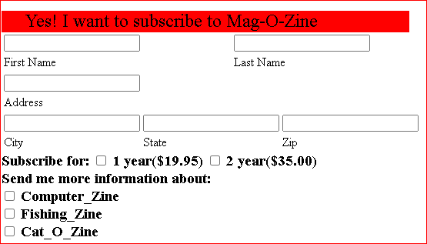

1. **Use the table tag to design given image**[**Click here**](https://www.bapugraphics.com/assets/img/port_upload_dir/table-4.jpg)**.**

**Answer 8:**

<!DOCTYPE html>

<html lang="en">

<head>

    <meta charset="UTF-8">

    <meta http-equiv="X-UA-Compatible" content="IE=edge">

    <meta name="viewport" content="width=device-width, initial-scale=1.0">

    <link rel="stylesheet" href="style11.8.css">

    <title>Document</title>

</head>

<style>

    #container {

        width: 800px;

        height: auto;

        margin: 50px auto;

    }

    table {

        width: 100%;

        border-collapse: collapse;

        font-family: 'Times New Roman', Times, serif;

    }

    table,

    td,

    th {

        border: 1px solid rgb(22, 20, 20);

        text-align: center;

    }

    th {

        padding: 10px;

    }

    td {

        padding: 10px;

    }

</style>

<body>

    <div id="container">

        <table>

            <tr>

                <th rowspan="2">State Of Health</th>

                <th height="60px" colspan="2">Fasting Value</th>

                <th>After Eating</th>

            </tr>

            <tr>

                <th>Minimum</th>

                <th>Maximum</th>

                <th>2 hours after eating</th>

            </tr>

            <tr>

                <td>Healthy</td>

                <td>70</td>

                <td>100</td>

                <td>Less than 140</td>

            </tr>

            <tr>

                <td>Pre-Diabetes</td>

                <td>101</td>

                <td>126</td>

                <td>140 to 200</td>

            </tr>

            <tr>

                <td>Diabetes</td>

                <td>More than 126</td>

                <td>N/A</td>

                <td>More than 200</td>

            </tr>

        </table>

    </div>

</body>

</html>

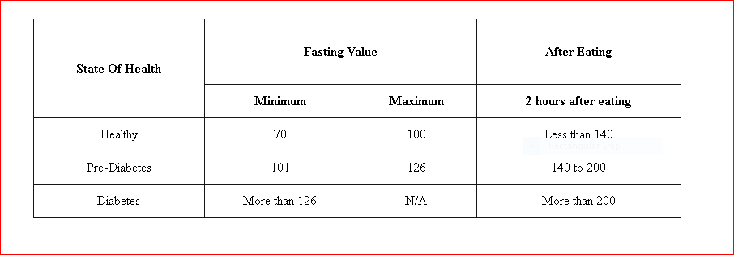

1. **Write HTML input tags snippet to show default values for all Form elements.**

**Answer 9:**

<!DOCTYPE html>

<html lang="en">

  <head>

    <meta charset="UTF-8" />

    <meta http-equiv="X-UA-Compatible" content="IE=edge" />

    <meta name="viewport" content="width=device-width, initial-scale=1.0" />

    <title>Document</title>

  </head>

  <body>

<section>

<form>

    <br id="contact">

        <h1 class="h-primary center">Contact Us</h1>

        <div id="contact-box">

            <br action="">

                <div class="form-group">

                    <label for="name">Name: </label>

                    <input type="text" name="name" id="name" placeholder="Enter your name">

                </div>

                <div class="form-group">

                    <label for="email">Email: </label>

                    <input type="email" name="name" id="email" placeholder="Enter your email">

                </div>

                <div class="form-group">

                    <label for="phone">Phone number: </label>

                    <input type="phone" name="name" id="phone" placeholder="Enter your phone">

                </div>

                <div class="form-group">

                    <label for="message">Message: </label>

                    <textarea name="message" id="message" cols="30" rows="10"></textarea>

                </div></br>

                <h4>Employee type</h4>

                <input type="radio" id="html" name="fav_language" value="HTML">

                <label for="html">Salaried</label><br>

                <input type="radio" id="css" name="fav_language" value="CSS">

                <label for="css">Own Business</label><br>

            </form>

        </div>

    </section>

</form>

  </body>

</html>

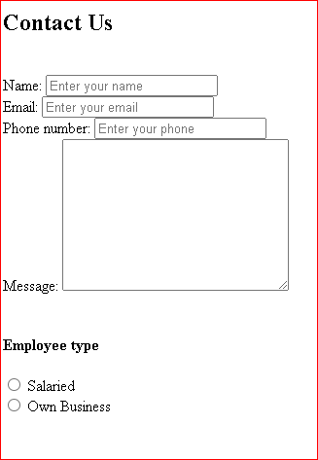

1. **In your, HTML page add the below line and Highlight it without using any CSS.**

* **"HTML & CSS is awesome"**

**Answer 10:**

<!DOCTYPE html>

<html lang="en">

<head>

    <meta charset="UTF-8">

    <meta http-equiv="X-UA-Compatible" content="IE=edge">

    <meta name="viewport" content="width=device-width, initial-scale=1.0">

    <title>Document</title>

</head>

<body>

    <div style="background-color: rgb(21, 196, 196);">

<p><ul type="disc">"HTML & CSS is awesome"</ul></p>

</div>

</body>

</html>

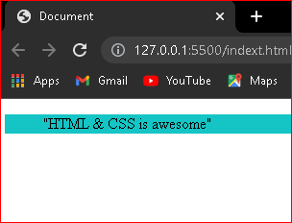

1. **Create an HTML page, which should contain all types of input elements.**

**Answer 11:**

<!DOCTYPE html>

<html lang="en">

  <head>

    <meta charset="UTF-8" />

    <meta http-equiv="X-UA-Compatible" content="IE=edge" />

    <meta name="viewport" content="width=device-width, initial-scale=1.0" />

    <title>Document</title>

  </head>

  <body>

<section>

<form>

    <br id="contact">

        <h1 class="h-primary center">Contact Us</h1>

        <div id="contact-box">

            <br action="">

                <div class="form-group">

                    <label for="name">Name: </label>

                    <input type="text" name="name" id="name" placeholder="Enter your name">

                </div>

                <div class="form-group">

                    <label for="email">Email: </label>

                    <input type="email" name="name" id="email" placeholder="Enter your email">

                </div>

                <div class="form-group">

                    <label for="phone">Phone number: </label>

                    <input type="phone" name="name" id="phone" placeholder="Enter your phone">

                </div>

                <div class="form-group">

                    <label for="message">Message: </label>

                    <textarea name="message" id="message" cols="30" rows="10"></textarea>

                </div></br>

                <h4>Employee type</h4>

                <input type="radio" id="html" name="fav_language" value="HTML">

                <label for="html">Salaried</label><br>

                <input type="radio" id="css" name="fav_language" value="CSS">

                <label for="css">Own Business</label><br>

            </form>

        </div>

    </section>

</form>

  </body>

</html>

